**Information on Linux and Commands**

What is Linux?

Linux is the most popular open-source operating system. Linux is the most secure and efficient operating system today, that is why almost all servers are run on Linux. Since it is open source, anyone can create their own distribution.

What is a distribution?

A Linux distribution, otherwise known as a distro, is a different version of Linux like MacOS and Windows have different versions. Every distro has different terminal commands, utilities, and graphical programs that run off of the “Linux kernel” or the core of the OS which is the same for every distro. You could technically make your own distro for whatever you need.

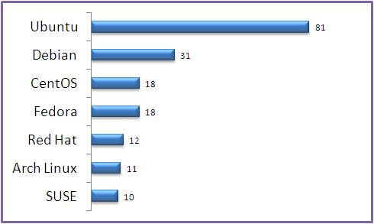

(Android and Chrome OS are Linux distributions)

Why learn Linux?

The Raspberry Pi runs on it’s own version of the Debian distro called Raspbian. This means to work with a Pi you must learn how to use Linux. Beyond the Raspberry Pi, many companies prefer using Linux on different development teams, and it is the best OS for working with creating your own projects because it is highly personalized.

Where did Linux come from?

A Finnish man named Linus Torvalds is famous for creating the Linux kernel which is now the core of every Linux distro. He was used to not having much software in Finland in the 80’s and created his own version of popular games like Pac-Man when he was younger. He then released the first version of the Linux kernel in 1991. More on him later...

Linux Commands to learn

sudo

Sudo: “substitute user do” or “super user do”

Sudo “commands”

nano myfile.txt

Nano: let’s you create, save, and edit files in any format

pwd

Pwd: Print working directory.

What’s a directory.

ls

Ls : list contents of current directory.

clear

Clear: clears terminal window

cd Desktop/

Cd: change directory.

This is how you navigate through folders.

Cd Desktop takes you to Desktop folder.

Now try ls?

cd ..

Cd .. takes you back

cd /

Cd / takes you to the root directory

cp file1.txt /folder/to/file2.txt

Cp: copy files

In same directory

Cp “file name” “new copy name”

In different directory

Cp “file name” “path of new directory”

rm filename.txt

Rm: remove or delete files

Rm “filename”

mkdir folderName

Mkdir: makes a new folder/directory

Mkdir “folder name”

rmdir folderName

Rmdir: delete an empty folder

Rmdir “folder name”

Let’s make a directory with a file in it then try to delete the directory with rmdir

rm -r folderName/

For directories with files in them you must use

Rm –r “file name”

man commandName

Man: gives you help with a command

Man “command”

sudo apt update

Apt: Advanced Package Tool

Allows users to install, upgrade, and clean packages

Sudo apt-get update